**LAB 4 Advanced Software Engineering**

**Implementing Web Services Using DataBase**

In this service I have created a service which can store name and phone number data into the database. Following the tutorials Web service was created using the Visual Studio 2013 as shown in the screenshots below:

Initially a new website was created.

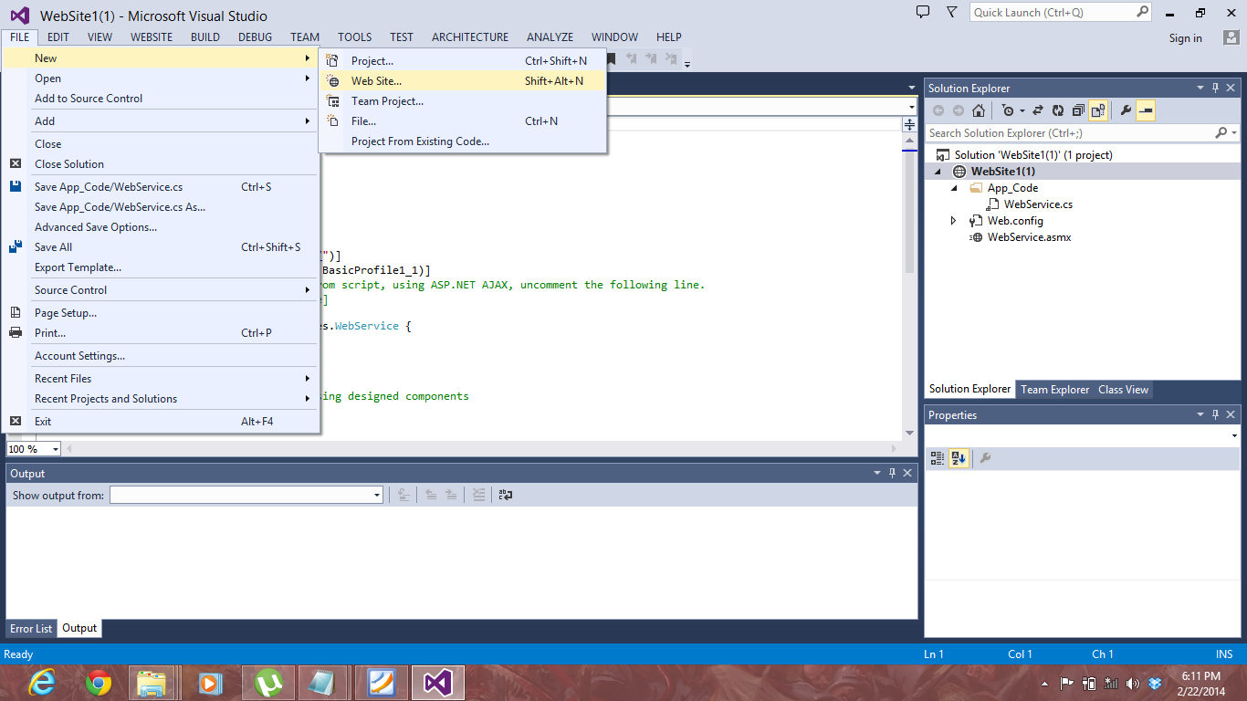

A new webservice was added to it.

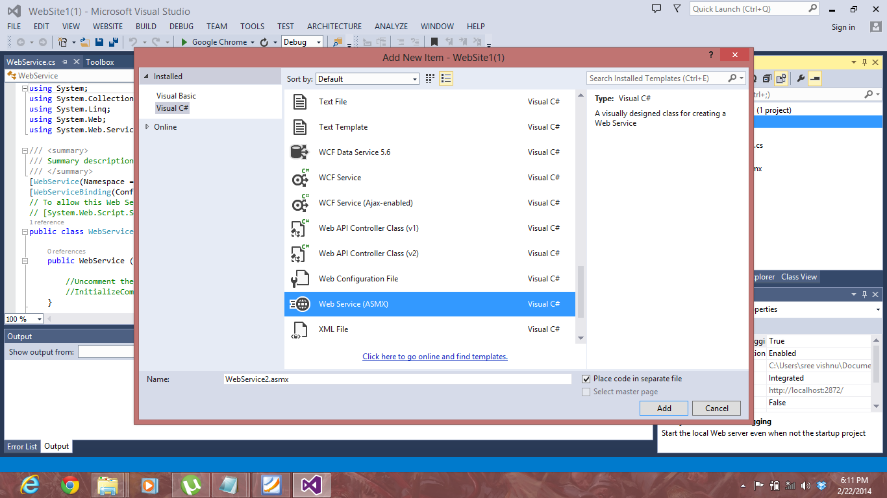

All the necessary code is written in the webservice.cs file.

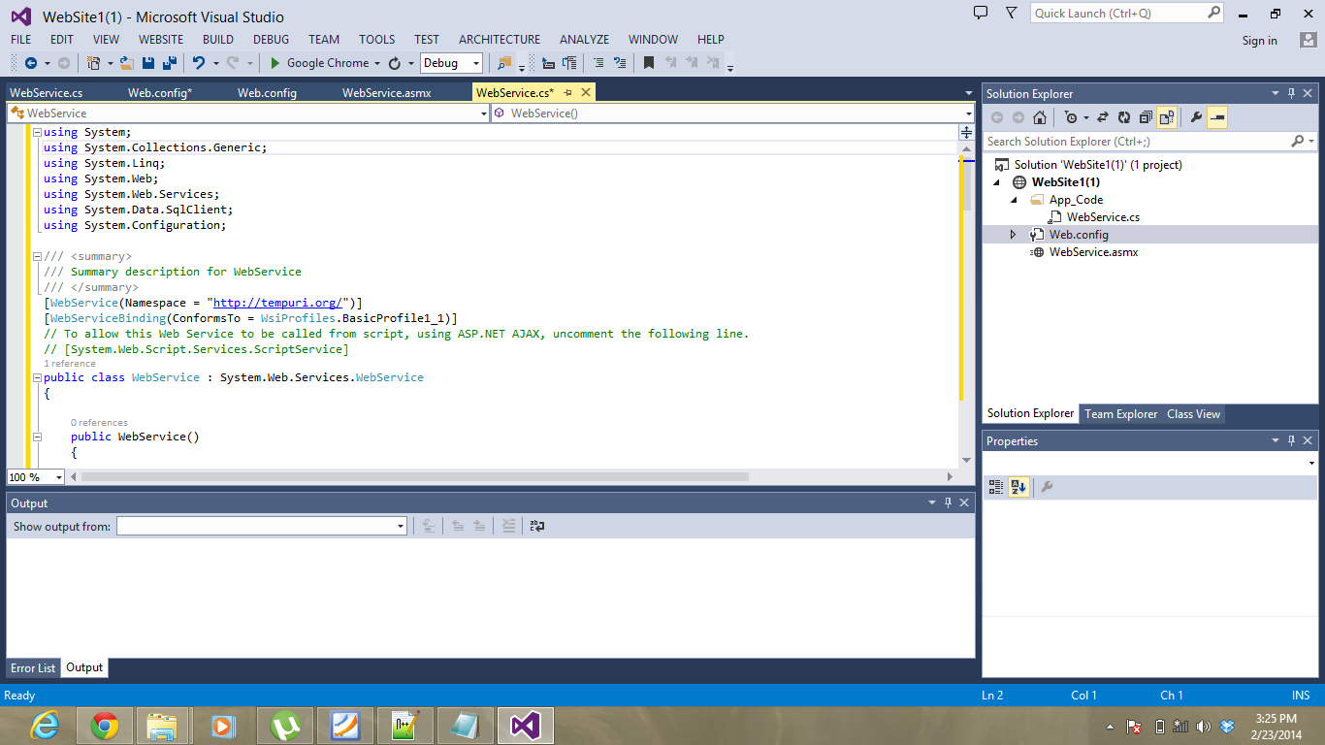

A database was added to the project.

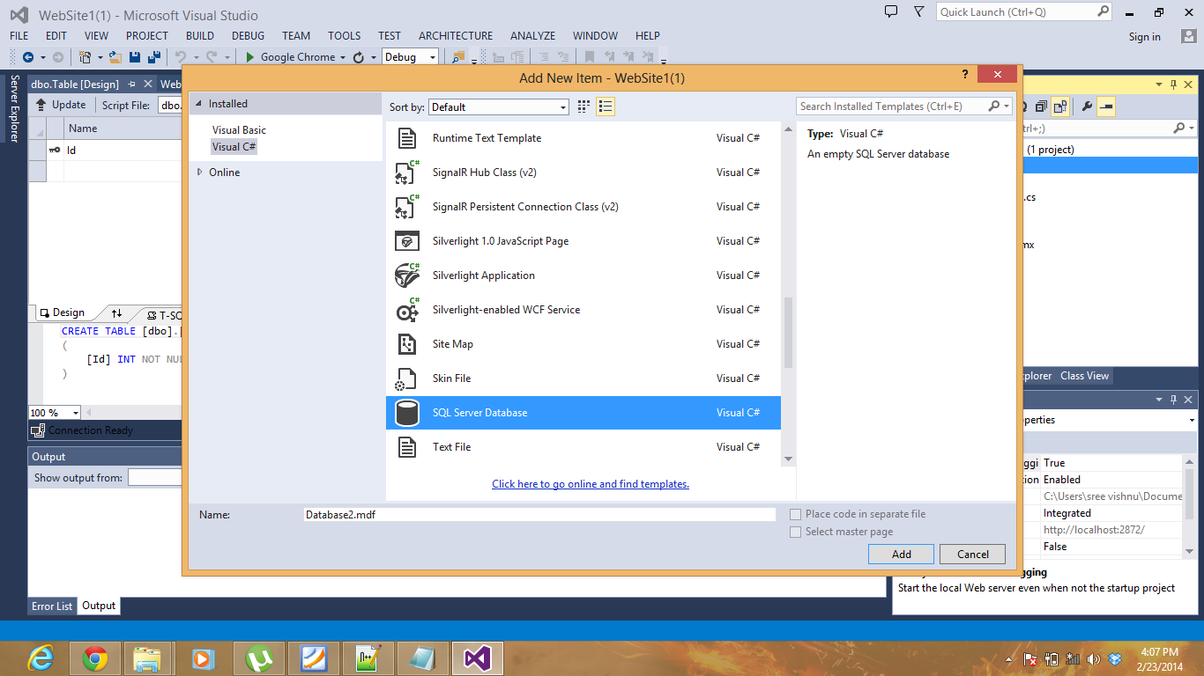

After adding the database a table with required columns was added.

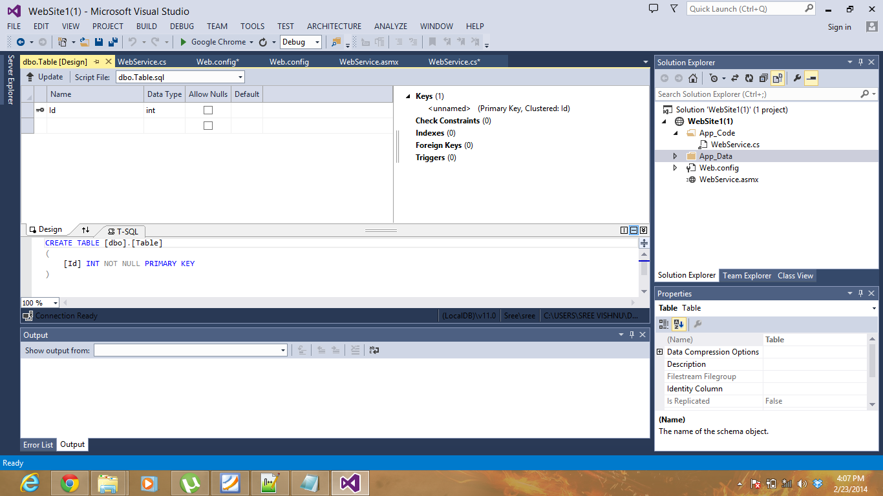

Now the project is viewed in the browser.

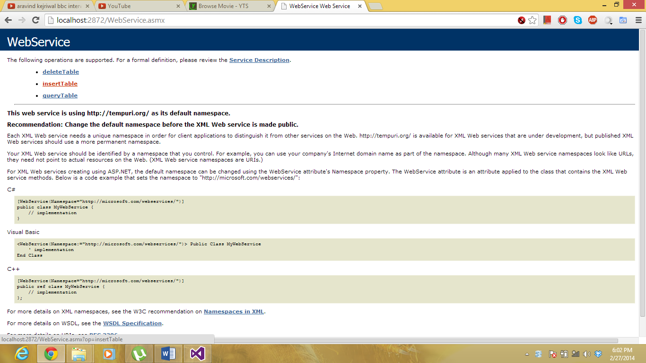

Inserttable service is selected and then name and number are entered.

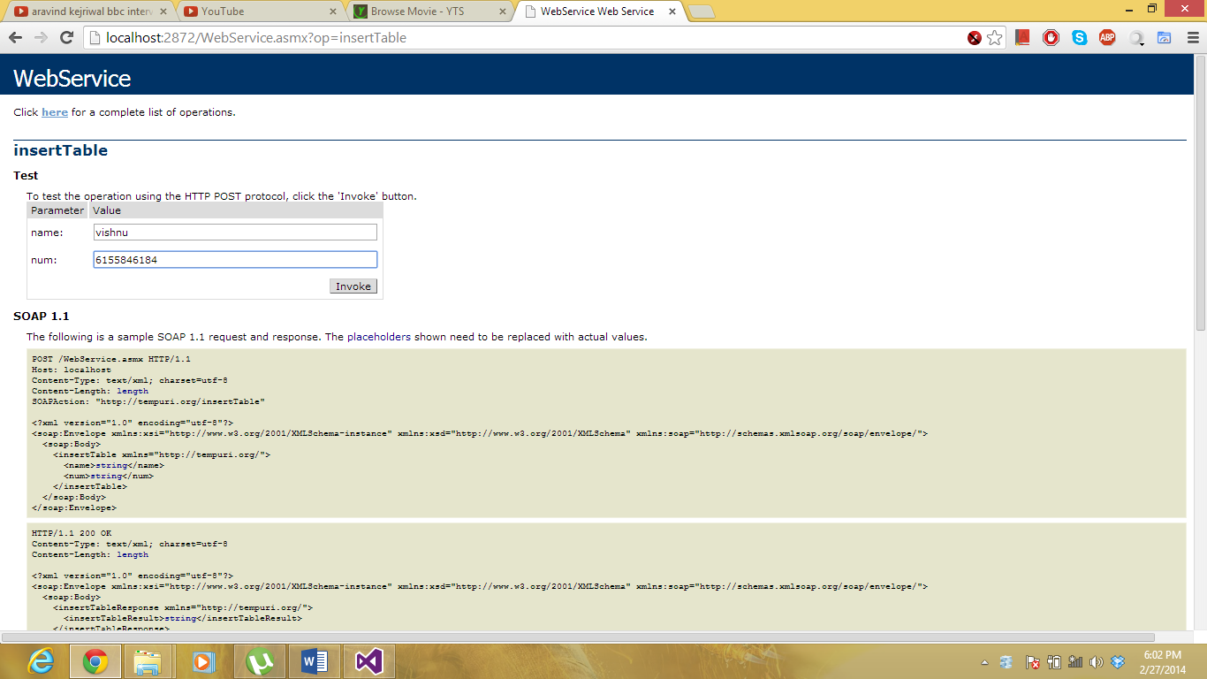

And now the service is invoke using invoke button.

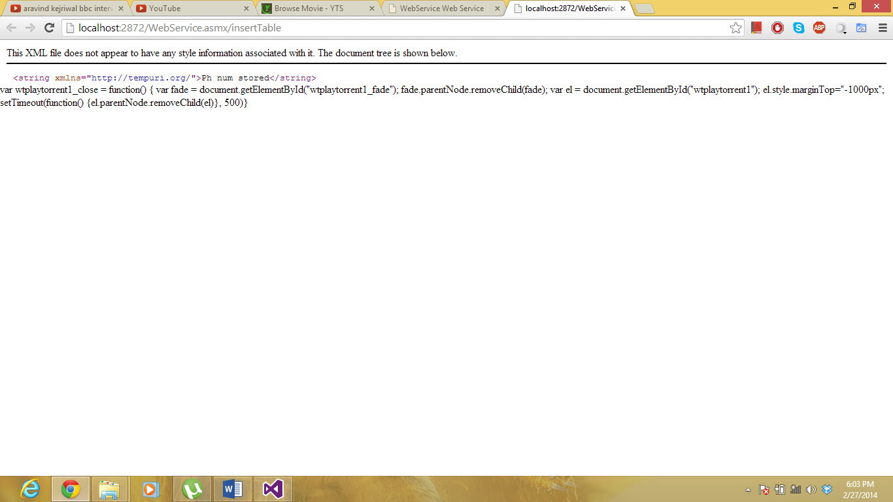

Now the querytable service is invoked.

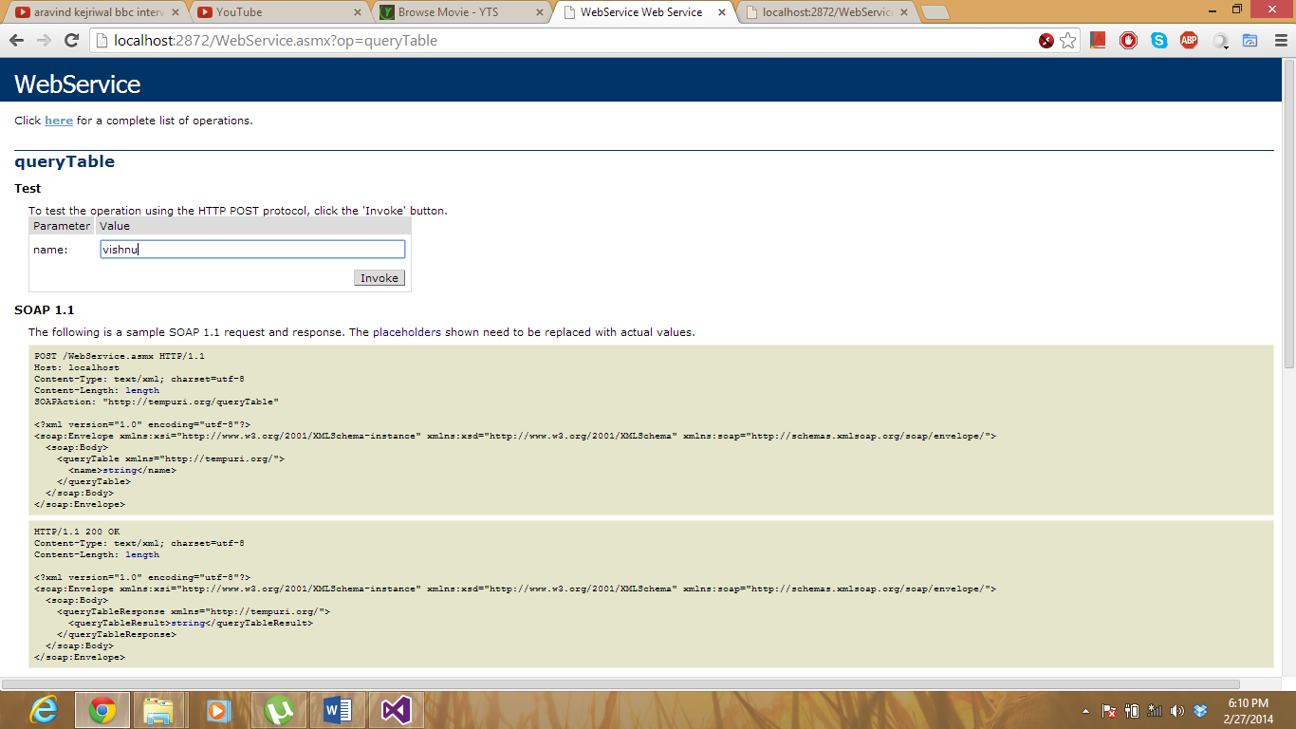

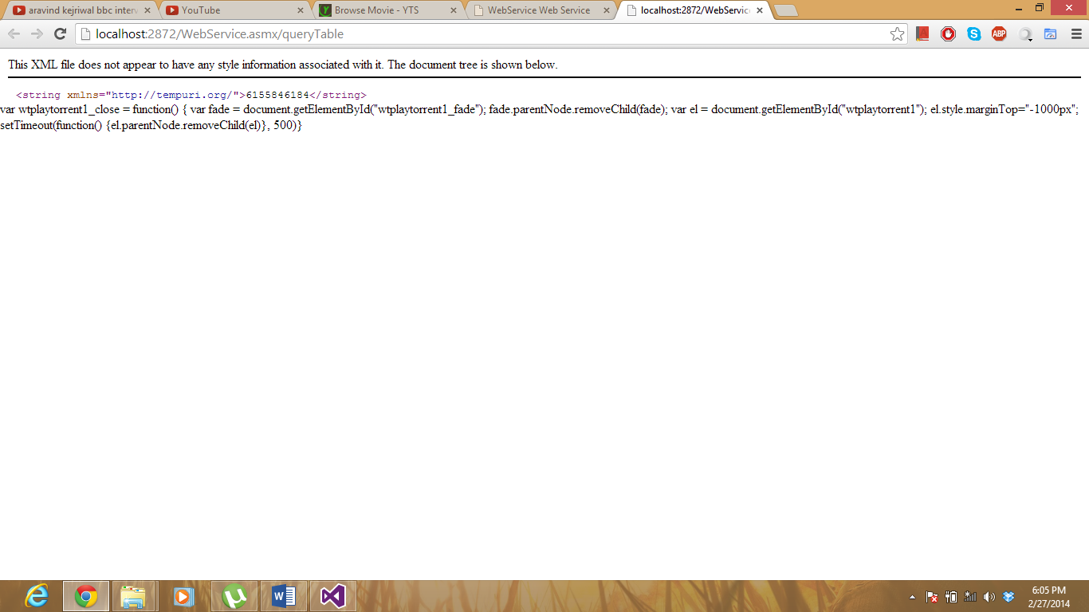

Now deletequery is selected:

